Structuring Data
Name: jasveena
Student ID: 224001588
Date: 1 -06 – 2024

“ I have taken the feedback from the tutor into strong consideration and fixed the errors in my submission .”

Learning Journey and Evidence

Review struct and enum custom types.
Struct: It is used to store multiple fields in a single composition value. We can create our own composite types using a struct. It is a building block we use in our code. And it contains fields that will exist within the variables we create using struct type . when we use the struct we access fields of the variable using the dot (.).

Enum: enum is an other kind of a type. It gives us the ability to define a list of values that type accepts. There is a slight difference between struct and enum that in enum we return these values from functions. And it lists the values that the type accepts. With using an enum we can use one of the names we declare in the type, convert it into an integer, or use a switch ststement with branches for the different values.

Create a small program with a struct – use it in a parameter, and as a function return type.
Show your process for this and highlight any realisations you gain.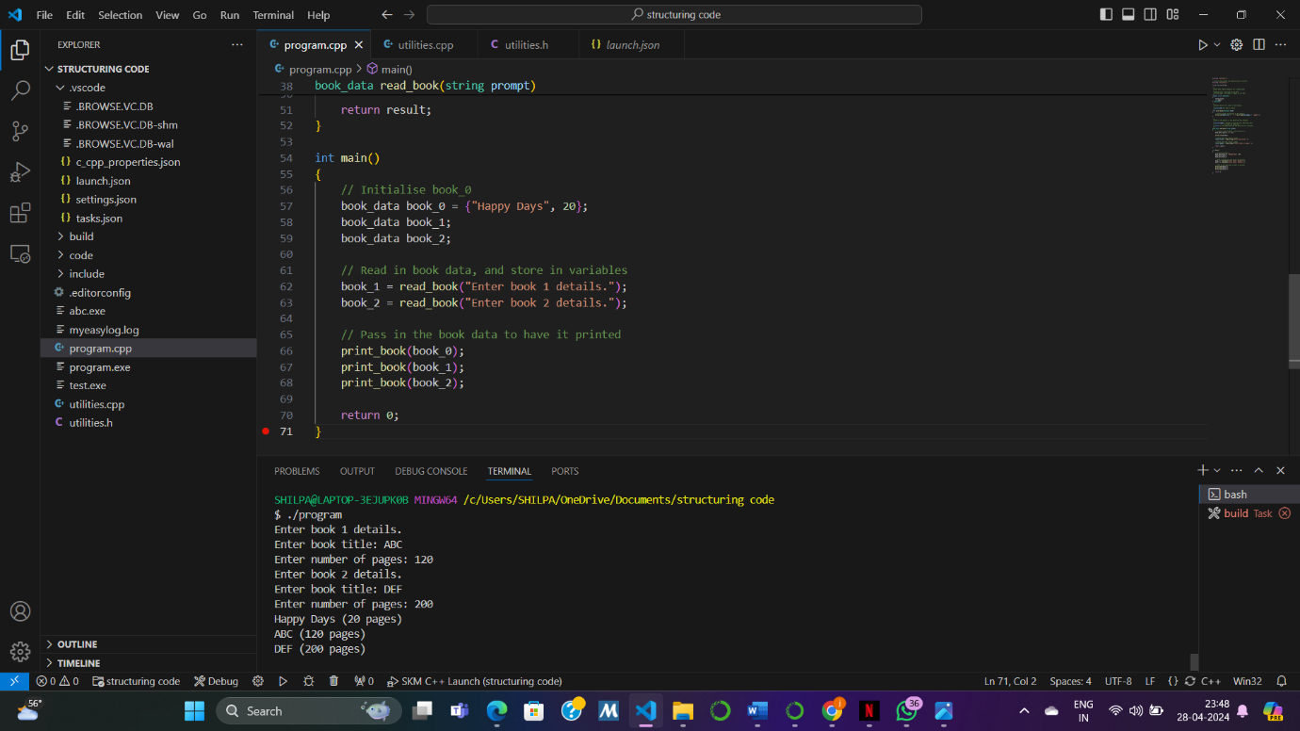

Create a small program with an enum – use it in a parameter, as a function return type, convert to a string and from user input.
Show your process for this and highlight any realisations you gain.
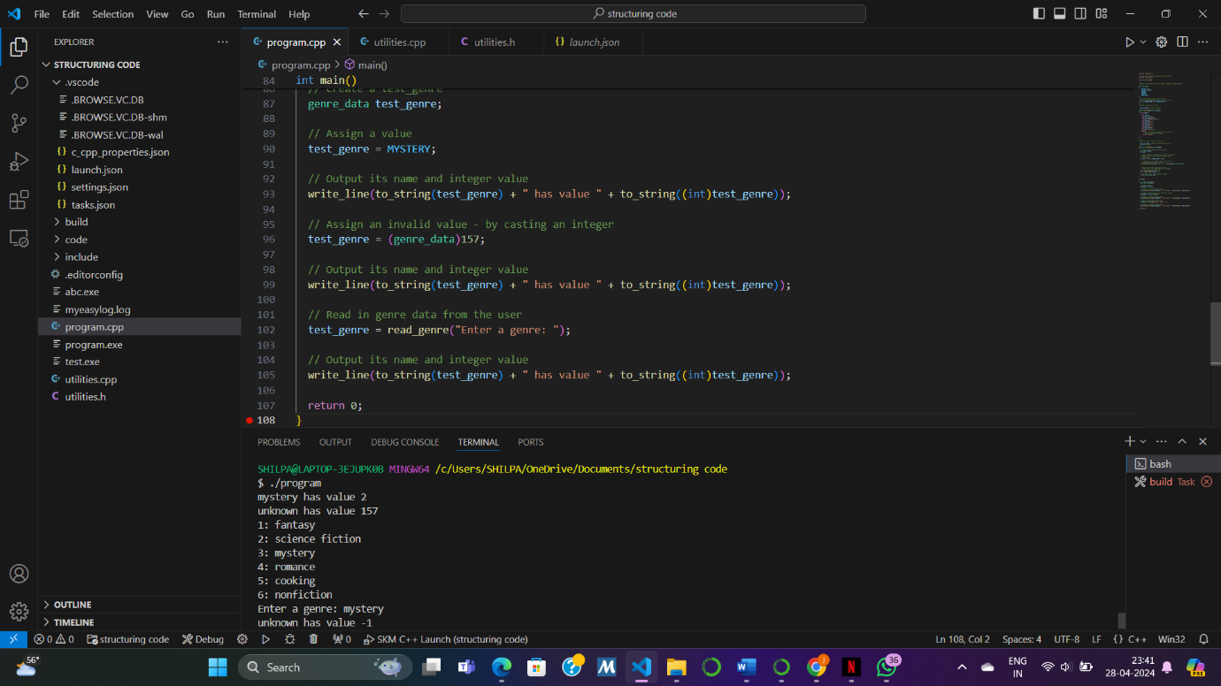

Build the Fly Catch program.

Create and use a spider_data struct – new spider and draw spider
Show your process for this and highlight any realisations you gain.

Create and use a fly_data struct – new fly, draw fly, time to appear/escape, and spider caught fly
Show your process for this and highlight any realisations you gain.

Create and use a game_data struct – draw game
Show your process for this and highlight any realisations you gain.
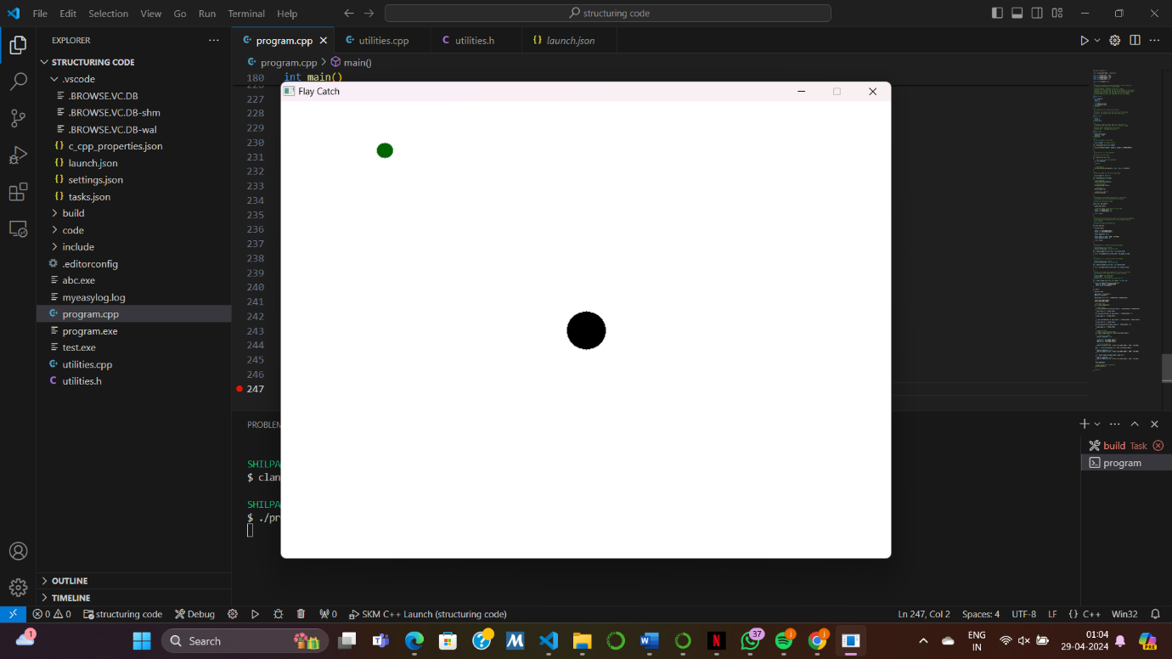

Capture any other study and practice used to master these concepts.
Show evidence of any additional study and practice you did to master these concepts.

Complete one of the Test Your Knowledge activities
Show your process for this and highlight any realisations you gain.
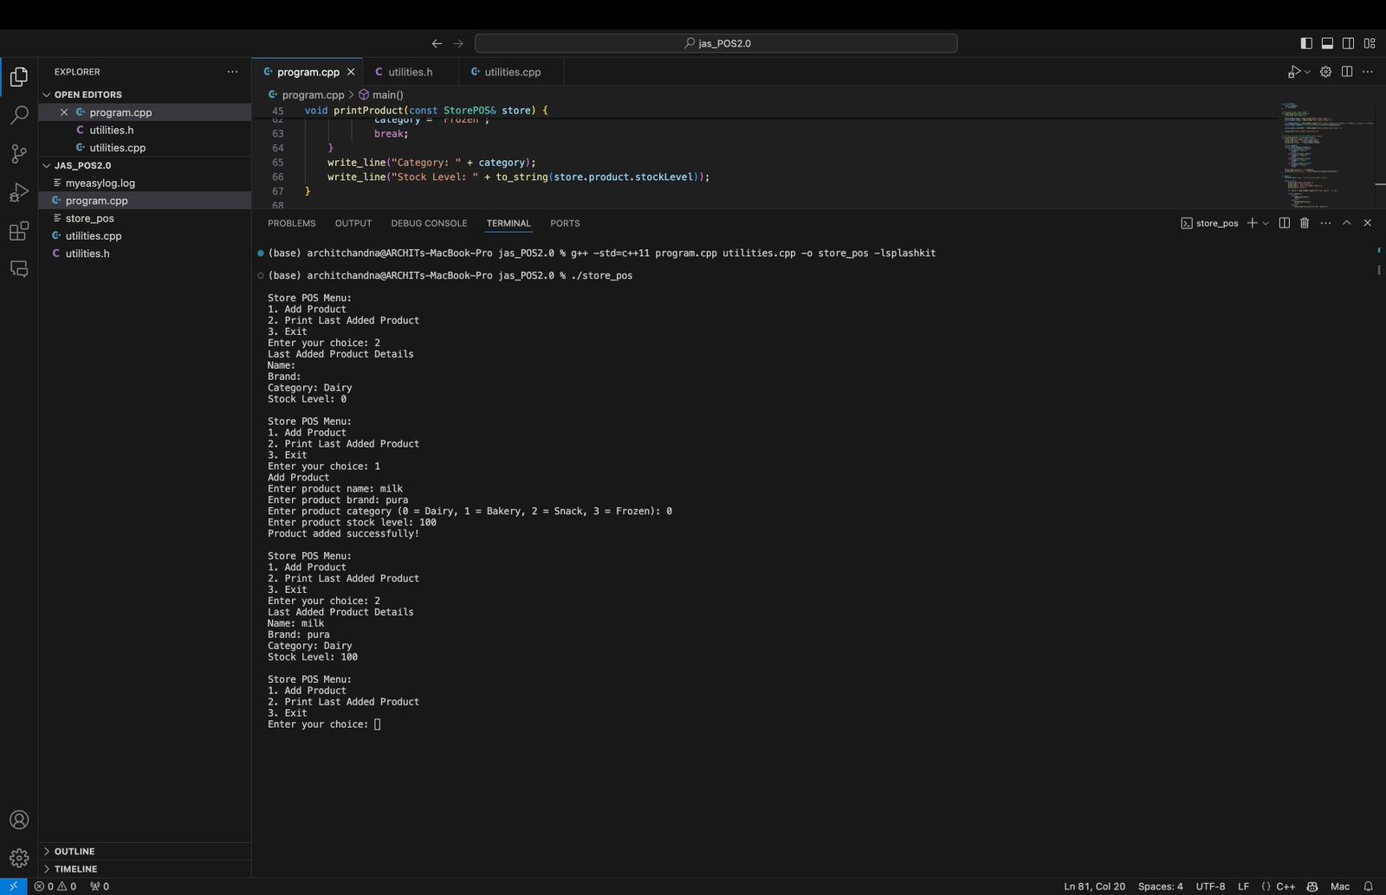

Brief Summary of Concepts
Concept | Key Idea / Concept
Struct | It is used to store multiple fields in a single composition value
Enum | It gives us the ability to define a list of values that type accepts

Reflection

What gives you confidence you have achieved the learning goals?

Create structs to organise your data into meaningful entities.
I feel confident that I have achieved the learning goals related to creating structs to organize data into meaningful entities because I have successfully demonstrated Understanding of Structs, Application of Structs, Integration of Structs, Utilization of Structs in Real-world Scenarios.

Create enumerations to capture discrete values where appropriate.
I am confident in achieving the learning goals related to creating enumerations because I have successfully defined and utilized enums to represent discrete values in my programs.

Use your custom types to with local variables, fields, parameters, and function return types.

I am confident in achieving the learning goals related to using custom types because I have successfully employed my custom types (structs and enums) as local variables, fields within other structs, parameters in functions, and function return types in my programs. This demonstrates my ability to effectively utilize custom types throughout the development process.

What is the most important thing you learned from this and why?
Answer this question here. A few sentences to a paragraph should be sufficient here.

The most important thing according to me was creating a new header file and compiling it with the previous one . It was a new concept I learned that we have to define sokme commands in other header files and compile them In order to make the program work.

